**GUVI**

**FULL STACK DEVELOPMENT – MERN**

**B51WD – ENGLISH**

**DAY 6 TASK – 24.08.2023**

**- BALAJI S**

**Q1. The class Movie is stated below. An instance of class Movie represents a film. This class has the following three properties:**

**title, which is a String representing the title of the movie**

**studio, which is a String representing the studio that made the movie**

**rating, which is a String representing the rating of the movie (i.e. PG­13, R, etc)**

**a) Write a constructor for the class Movie, which takes a String representing the title of the movie, a String representing the studio, and a String representing the rating as its arguments, and sets the respective class properties to these values.**

**b) The constructor for the class Movie will set the class property rating to "PG" as default when no rating is provided.**

**c) Write a method getPG, which takes an array of base type Movie as its argument, and returns a new array of only those movies in the input array with a rating of "PG". You may assume the input array is full of Movie instances. The returned array need not be full.**

**d) Write a piece of code that creates an instance of the class Movie with the title “Casino Royale”, the studio “Eon Productions”, and the rating “PG­13”**

<script>

        class Movie{

            constructor(title,studio,rating){

                this.title = title;

                this.studio = studio;

                if(rating == null){

                    return this.rating = "PG13";

                }

                else{

                    this.rating = rating;

                }

            }

            static getPG(movies){

                var pgMovies = [];

                for(var i=0;i<movies.length;i++){

                    if(movies[i].rating === "PG")

                        pgMovies.push(movies[i]);

                }

                return pgMovies;

            }

        }

        var film1 = new Movie("Casino Royale","EON Productions","PG13");

        var film2 = new Movie("IronMan","Marvel");

        var film3 = new Movie("Barbie", "Warner Bros", "PG");

        var film4 = new Movie("Oppenheimer", "Universal", "R");

        var film5 = new Movie("Thor", "Marvel", "PG-13");

        console.log(film1.title);

        console.log(film2.rating);

        var moviesArray = [film1,film2,film3,film4,film5];

        var result = Movie.getPG(moviesArray);

        console.log(result);

    </script>

**Output:**

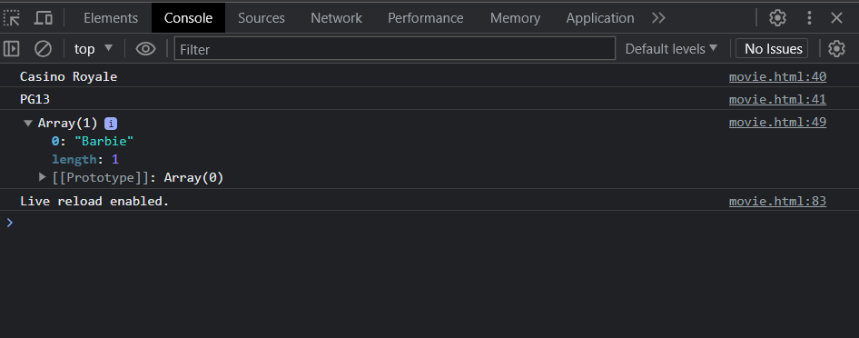

**Q2.Converting the diagram to Typescript class.**

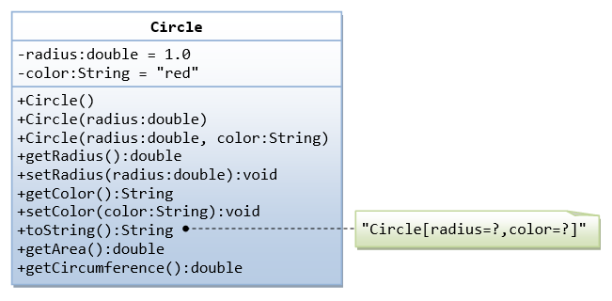

class Circle{

            constructor(radius,color){

                this.radius = radius;

                this.color = color;

            }

            getRadius(){

                console.log(`The radius is ${this.radius}`);

            }

            getColor(){

                console.log(`The color is ${this.color}`);

            }

            getArea(){

                var x = Math.PI;

                return x * this.radius * this.radius;

            }

            getCircumference(){

                var x = Math.PI;

                return 2 * x * this.radius;

            }

        }

        var obj1 = new Circle(2.0,"Red");

        obj1.getRadius();

        obj1.getColor();

        var area = obj1.getArea();

        console.log(area);

        var circumference = obj1.getCircumference();

        console.log(circumference);

    </script>

**Output:**

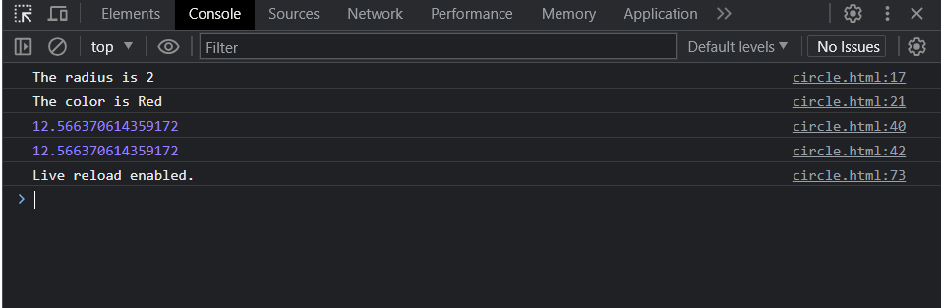

**Q3.Write a person class to hold all the details.**

<script>

        class Person{

            constructor(firstName,lastName,age,address,number,mail){

                this.firstName = firstName;

                this.lastName = lastName;

                this.age = age;

                this.address = address;

                this.number = number;

                this.mail = mail;

            }

            display(){

                console.log(`Hi,My name is ${this.firstName} ${this.lastName}`);

                console.log(`Age:${this.age}`);

                console.log(`Address:${this.address}`);

                console.log(`Number:${this.number}`);

                console.log(`Mail:${this.mail}`);

            }

        }

        var person1 = new Person("Balaji","S",22,"Chennai","123456789","xyz@gmail.com");

        person1.display();

    </script>

**Output:**

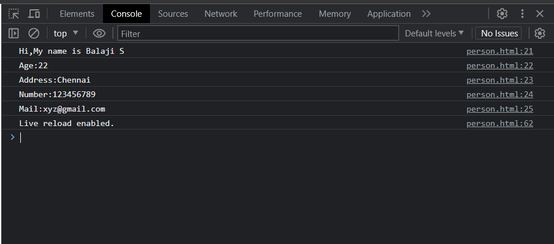

**Q4.Write a class to calculate the uber price.**

<script>

        class Price{

            constructor(baseFare,costPerKm,costPermin,bookingFee){

                this.baseFare = baseFare;

                this.costPerKm = costPerKm;

                this.costPermin = costPermin;

                this.bookingFee = bookingFee;

            }

            calculatePrice(distance,duration){

                var distancePrice = distance * this.costPerKm;

                var minPrice = duration * this.costPermin;

                var price = distancePrice + minPrice + this.baseFare + this.bookingFee;

                return price;

            }

        }

        var trip = new Price(10,4,2,5);

        var distance = 10;

        var duration = 30;

        var totalPrice = trip.calculatePrice(distance,duration);

        console.log(totalPrice);

    </script>

**Output:**

